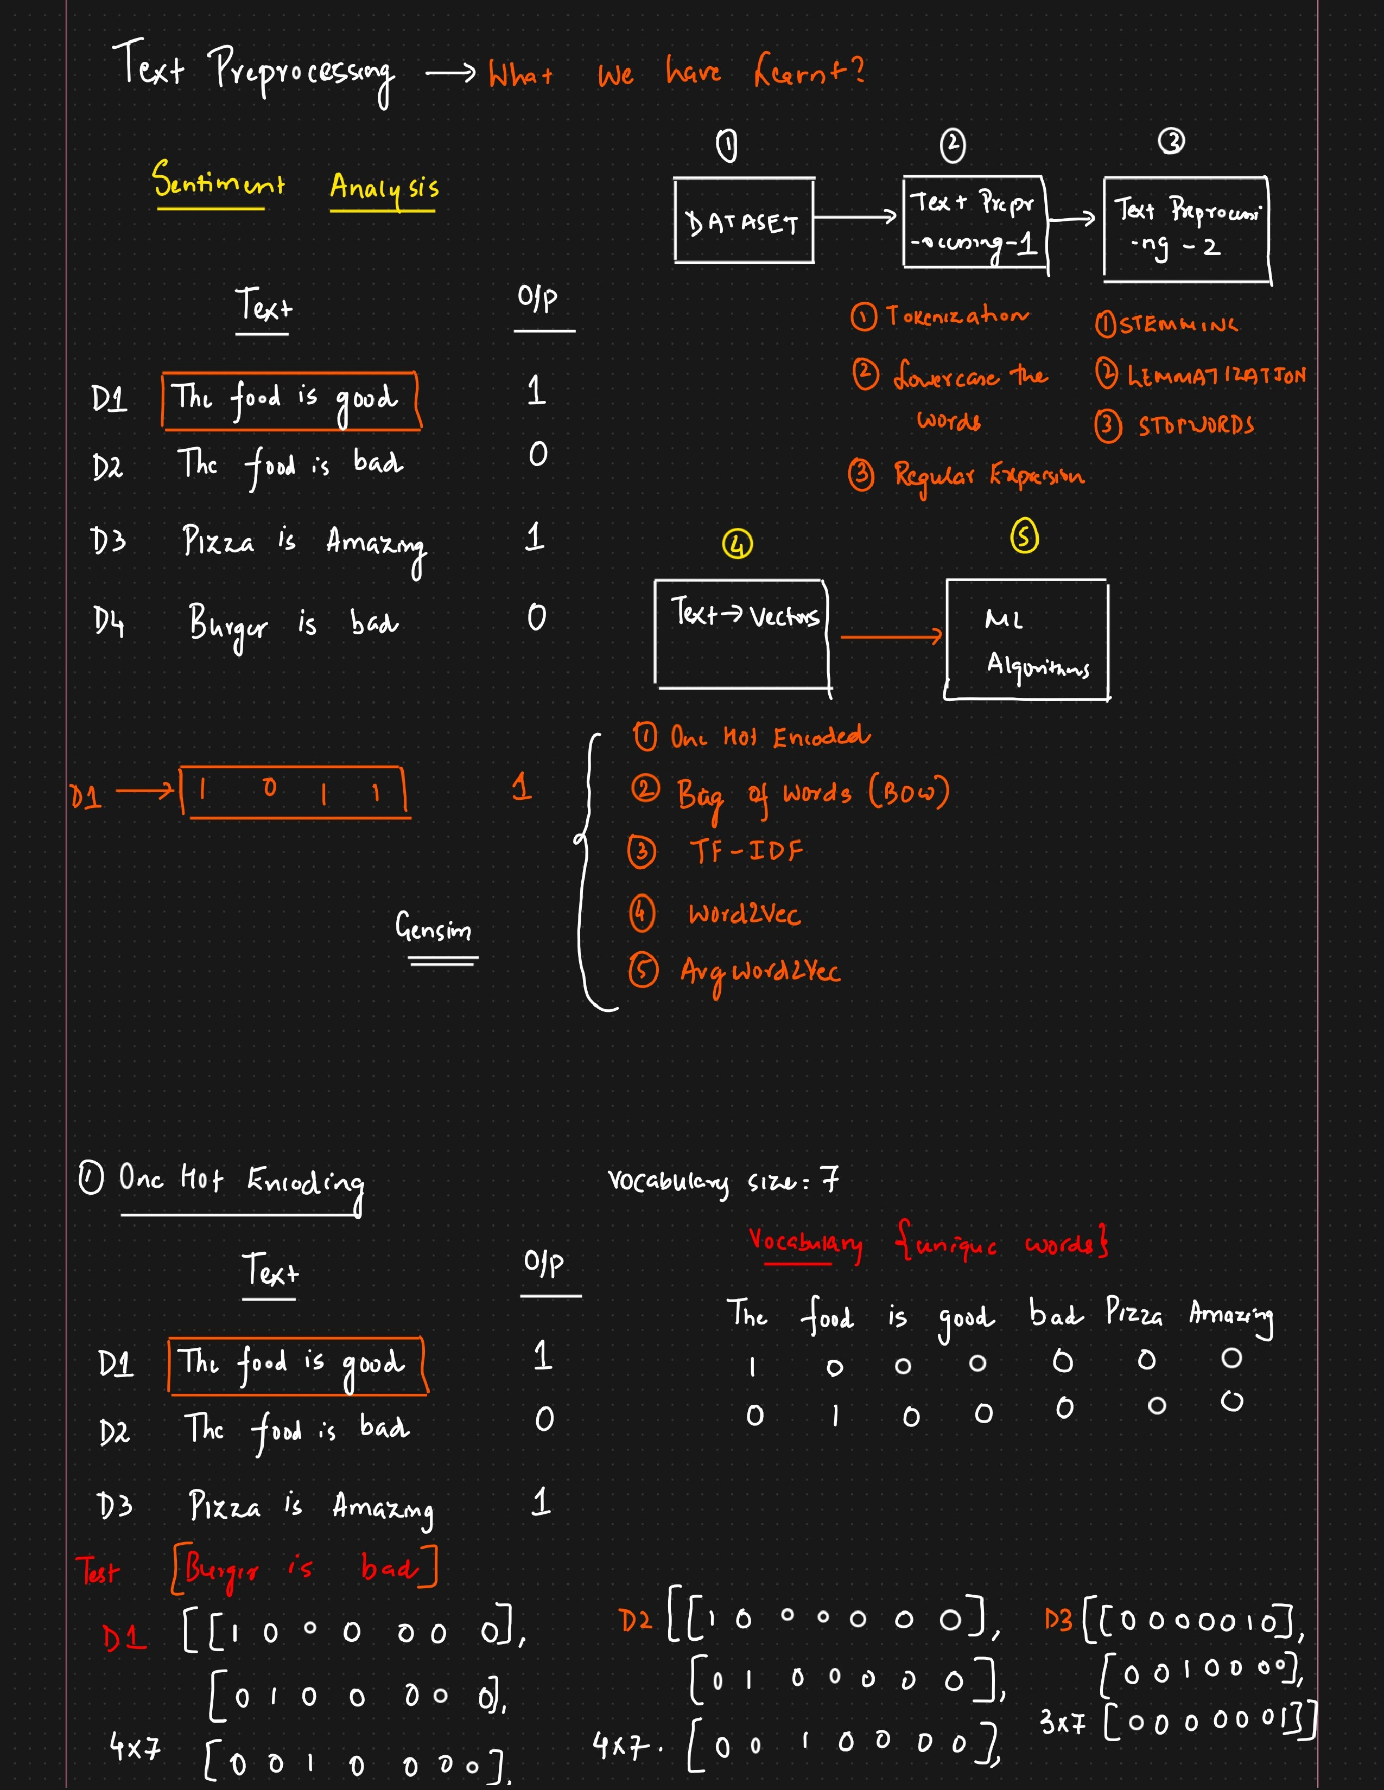

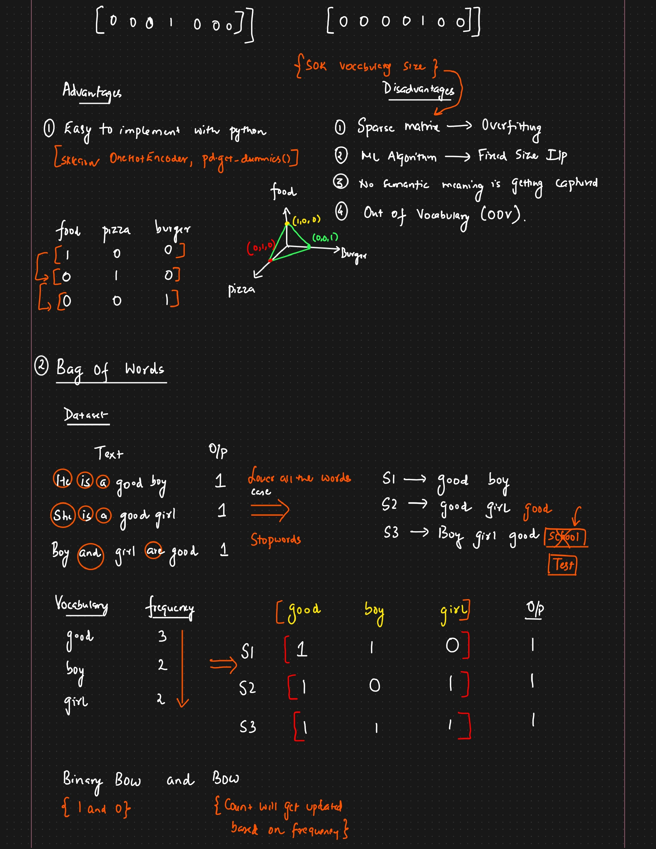

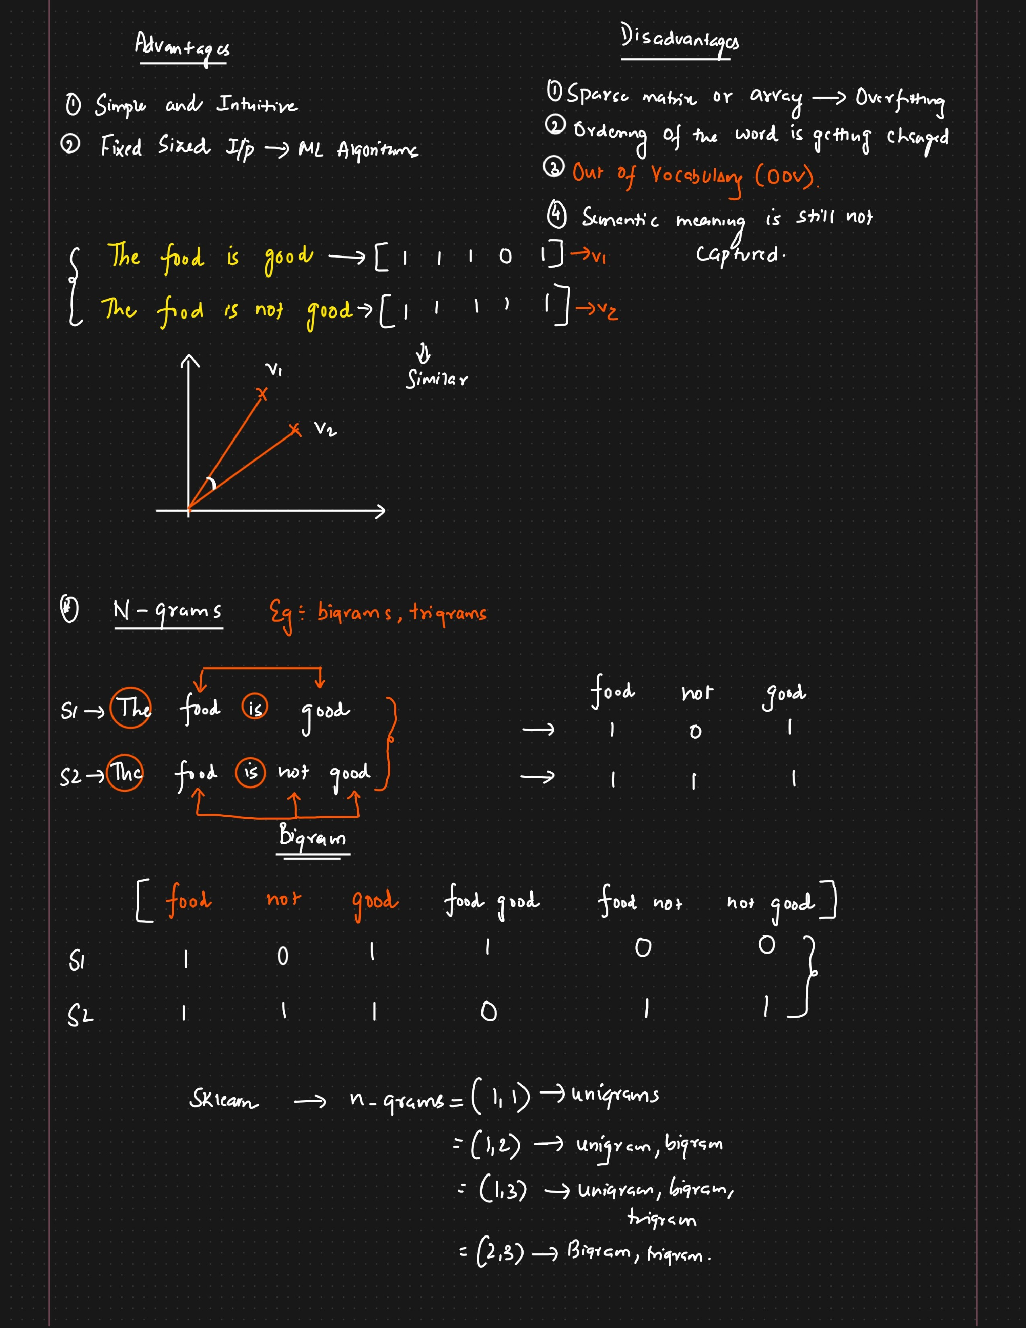

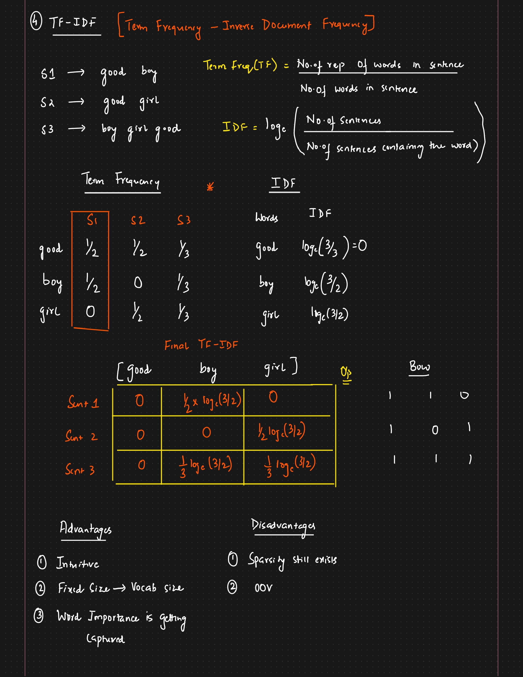

kf0MJv s 1012

In natural language processing (NLP), word embedding is a term used for the representation of words for text analysis, typically in the form of a real-valued vector that encodes the meaning of the word such that the words that are closer in the vector space are expected to be similar in meaning.

h4Ppy

3 gen%nc.z Vet-fus

Gunt Dec p

Moact

h)Dtd2vec

0

# BAA k)D2DS]

k.JOYd2 Nec GO le

Word2vec is a technique for natural language processing published in 2013. The word2vec algorithm uses a neural network model to learn word associations from a large corpus of text. Once trained, such a model can detect synonymous words or suggest additional words for a partial sentence. As the name implies, word2vec represents each distinct word with a particu ar Isto num ers ca e a vector.

—.....9 Coypus

Qe-ndes o.os

0.0 L o•qS

003 o•qc

O•qz

FOO

